CME1001 Algorithms and Programming I
LAB 4

Exercises

1- Write a program that takes a digit (between 1 and 9) from the user and finds the type of the digit.

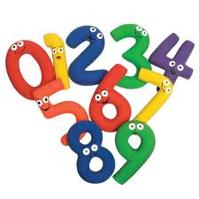
Note: Use switch-case structure.

Digit | Type
1, 4, 9 | Perfect Square
2, 6, 8 | Even number
3, 5, 7 | Prime number

Example:
Input: 4
Output: Perfect Square

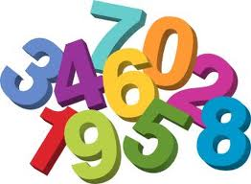
2- Write a loop that prints the following output on the screen.

6 11 16 21 26 31 36 41 46 51 56 61 66 71 76

Note: Use for loop

3- Write a program that takes lower and upper limits from the user and then calculates the sum of all the integer squares from the lower limit to the upper limit.


Example:
Inputs: 5 9
Output: 255 (i.e. 25 + 36 + 49 + 64 + 81)

Example:
Inputs: 3 25
Output: 5520 (i.e. 9 + 16 + 25 + ...+ 625)

4- Write a program which that takes the value of m from the user and calculates the result of the following mathematical formula:

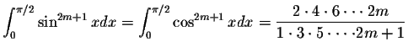

5- Write a program that prints the following Metric Conversion Chart.

inch inch mm

1/64 0.016 0.397
2/64 0.031 0.794
3/64 0.047 1.191
4/64 0.063 1.588
5/64 0.078 1.984
3/32 0.094 2.381
7/64 0.109 2.778
8/64 0.125 3.175
9/64 0.141 3.572
10/64 0.156 3.969
11/64 0.172 4.366
12/64 0.188 4.763
13/64 0.203 5.159
14/64 0.219 5.556
15/64 0.234 5.953
16/64 0.250 6.350
17/64 0.266 6.747
18/64 0.281 7.144
19/64 0.297 7.541
10/64 0.313 7.938
21/64 0.328 8.334
22/64 0.344 8.731
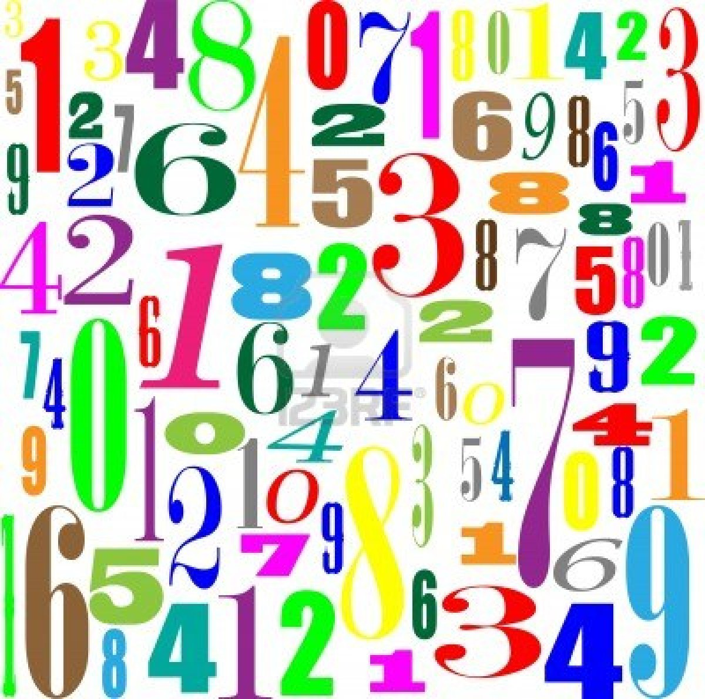
6- Write a program that takes 7 numbers from the user and prints out how many times the first number is repeated and their positions.

Example:
Inputs: 5 9 34 65 5 82 5
Output: 2 times
Positions: 5 7

Example:
Inputs: 16 16 8 10 20 16 16
Output: 3 times
Positions: 2 6 7

7- Write a program that reads in a sequence of non-zero 8 real numbers between -1 and 1 and prints out the number of zero crossings.

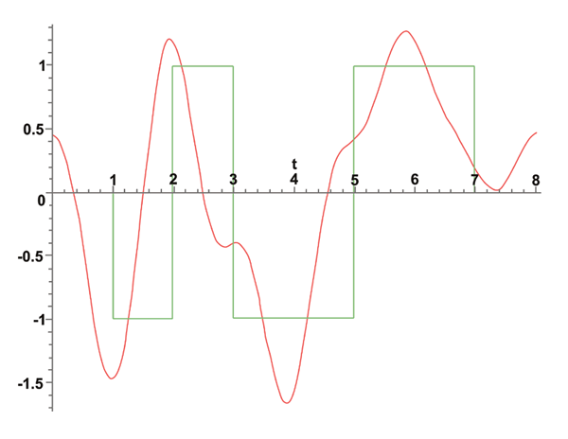
The number of zero crossings is the number of times a data value transitions from a strictly negative number to a strictly positive number, or vice versa. This is widely used to analyze digital signals.

Example:
Inputs: 0.8 -0.2 0.4 0.6 0.1 -0.5 -0.7 0.2
Output: 4 times

8- Assume that we have three three-sided dices.
Dice1 {2, 6, 7}
Dice2 {1, 5, 9}
Dice3 {3, 4, 8}
A player rolls the dices until they come up 1, 2 and 3.
The program should print “how many times the dices rolled before they come up 1-2-3.

Note: Use while loop


Example:
Output:
1. try 2 5 8
2. try 7 5 3
3. try 6 9 4
4. try 7 9 8
5. try 2 1 3

after 5 times !

9- Write a program to compute the interest on a bank account month by month.
The user will enter the deposit amount ($), interest rate (%) and the number of months.

Inputs:
Starting Balance: $ 1000.00
Interest Rate (per year): 5.0

Number of months: 24
Output:

Month Interest Principal
1 $4.17 $1004.17
2 $4.18 $1008.35
3 $4.20 $1012.55
4 $4.22 $1016.77
5 $4.24 $1021.01
6 $4.25 $1025.26
7 $4.27 $1029.53
8 $4.29 $1033.82
9 $4.31 $1038.13
10 $4.33 $1042.46
11 $4.34 $1046.80
12 $4.36 $1051.16
13 $4.38 $1055.54
14 $4.40 $1059.94
15 $4.42 $1064.36
16 $4.43 $1068.79
17 $4.45 $1073.24
18 $4.47 $1077.72
19 $4.49 $1082.21
20 $4.51 $1086.72
21 $4.53 $1091.24
22 $4.55 $1095.79
23 $4.57 $1100.36
24 $4.58 $1104.94

10- Write a program that prints the second largest of given 8 numbers.

Example :
Inputs:

Output: 16

11- Write a program using a loop to print the following time information.
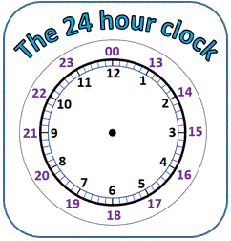
12 midnight
1am
2am
...
12 noon
1pm
...
11pm


12- A bank account starts out with $10,000. Interest is compounded monthly at 6% per year (0.5% per month).
Every month, $500 is withdrawn to meet college expenses.
Write a program that finds “After how many months is the account depleted?”.

Questions

Upload the answers of the following questions from http://lectures.cs.deu.edu.tr/ web site until October 25, 2015.

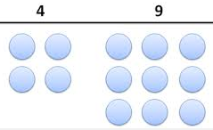
1- Write a program that takes a number n (between 1 and 999) from the user and finds “how many times the digits 4 and 9 occurs from 1 to n”.

Example :
Input: 100
Output: 40

(because 4 9 14 19 24 29 34 39 49 41 42 43 44 45 46 47 48 49 54 59 64 69 74 79 84 89 90 91 92 93 94 95 96 97 98 99)

2- Write a C# program that takes a number from the user and prints one of the followings:
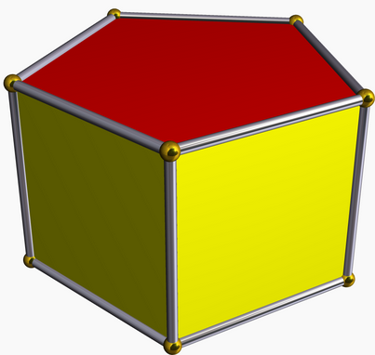
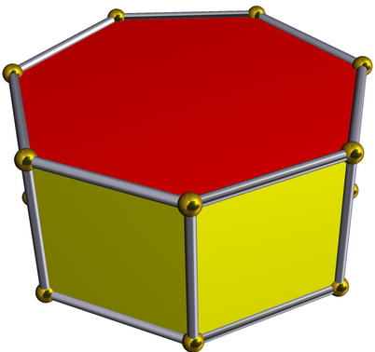
- pentagonal and heptagonal
- Not pentagonal but heptagonal
- Pentagonal but not heptagonal
- Neither pentagonal nor heptagonal

A pentagonal number is a number of the form P_{n} = n(3n−1)/2.
The first few are 1, 5, 12, 22, 35, 51, 70, 92, 117, 145, 176, 210, 247, 287, 330, 376, 425, 477, 532, 590, 651, 715, 782, 852, 925, 1001... etc.

A heptagonal number is a number of the form H_{n} = n(5n-3)/2.
The first few are 1, 7, 18, 34, 55, 81, 112, 148, 189, 235, 286, 342, 403, 469, 540, 616, 697, 783, 874, 970, 1071... etc.

Examples:
Input: 4347 Input: 590
Output: pentagonal and heptagonal Output: Pentagonal but not heptagonal

3- Write a program which that takes the values of x and a from the user and calculates the result of the following mathematical formula:


